**Chapter 1** 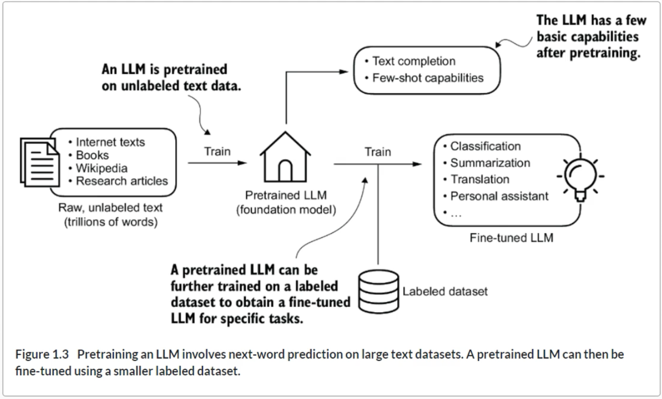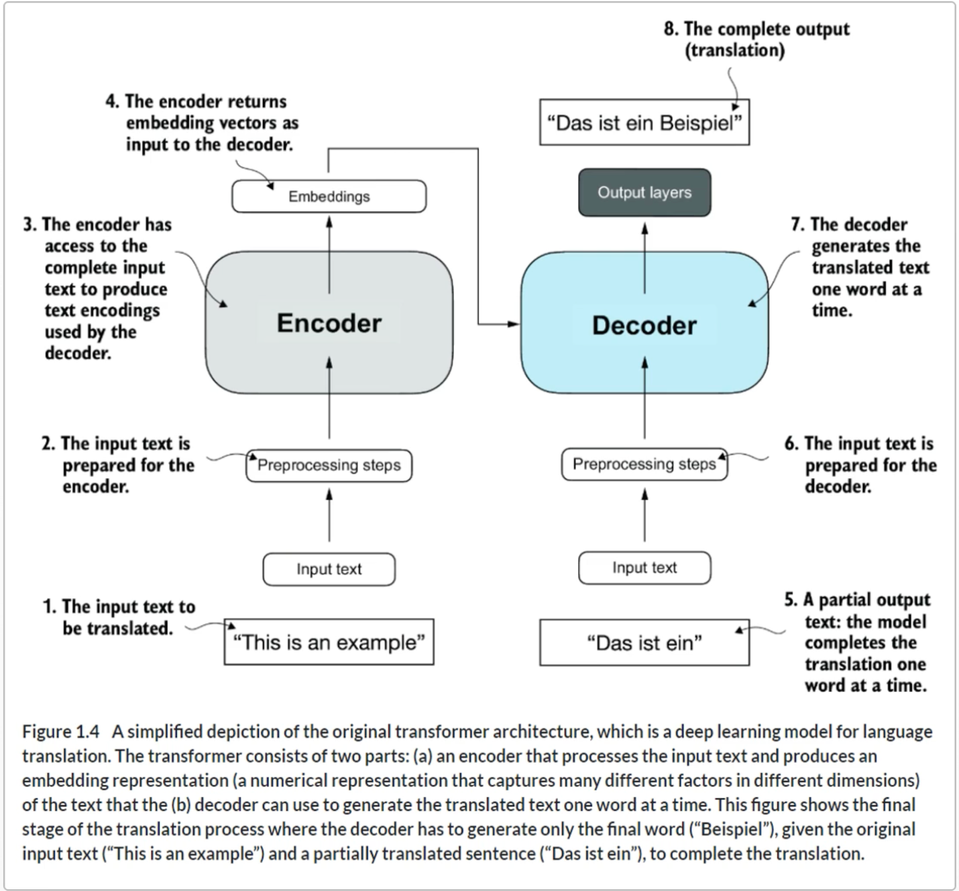

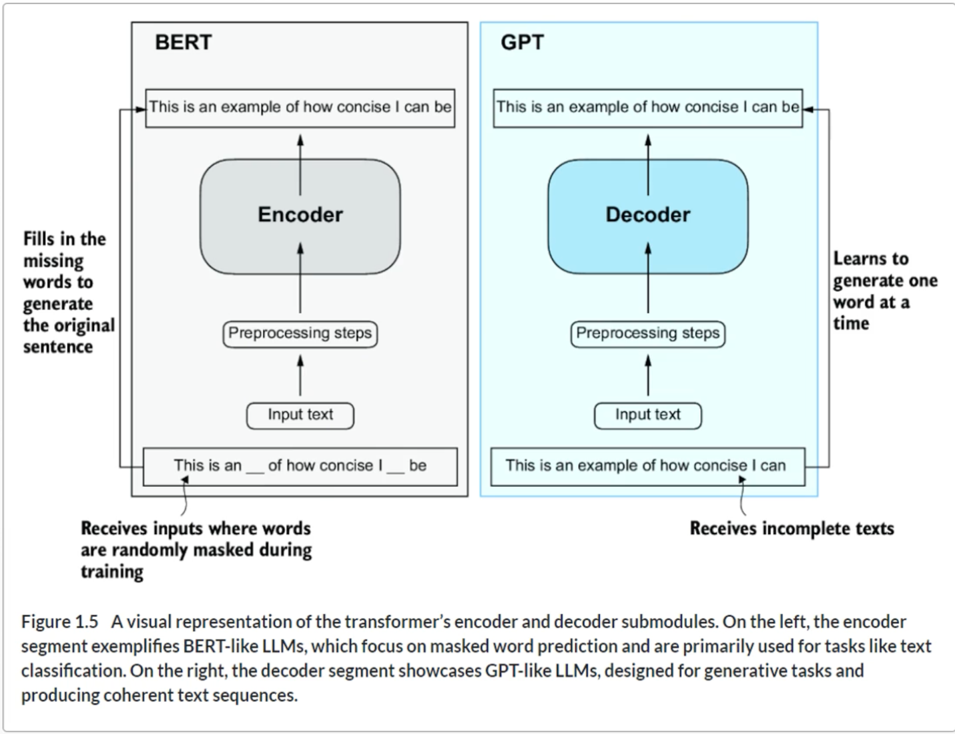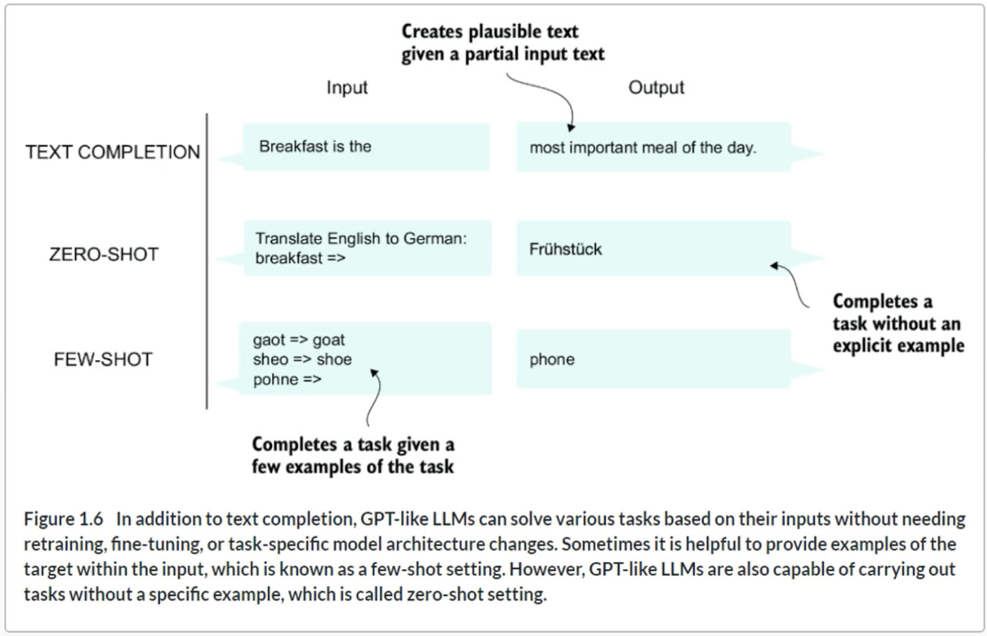

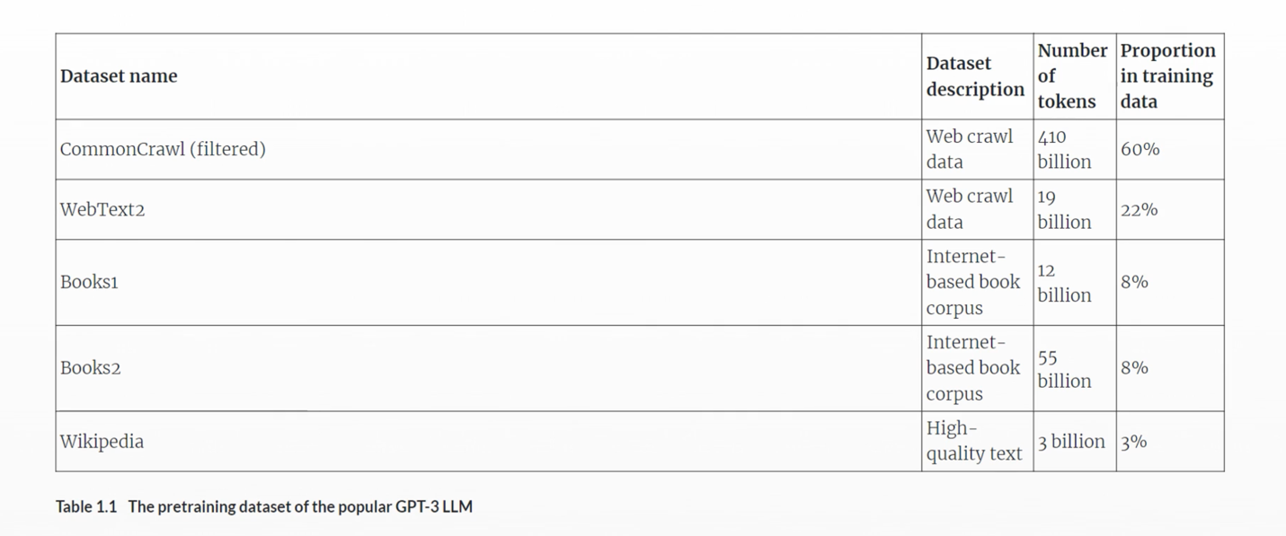

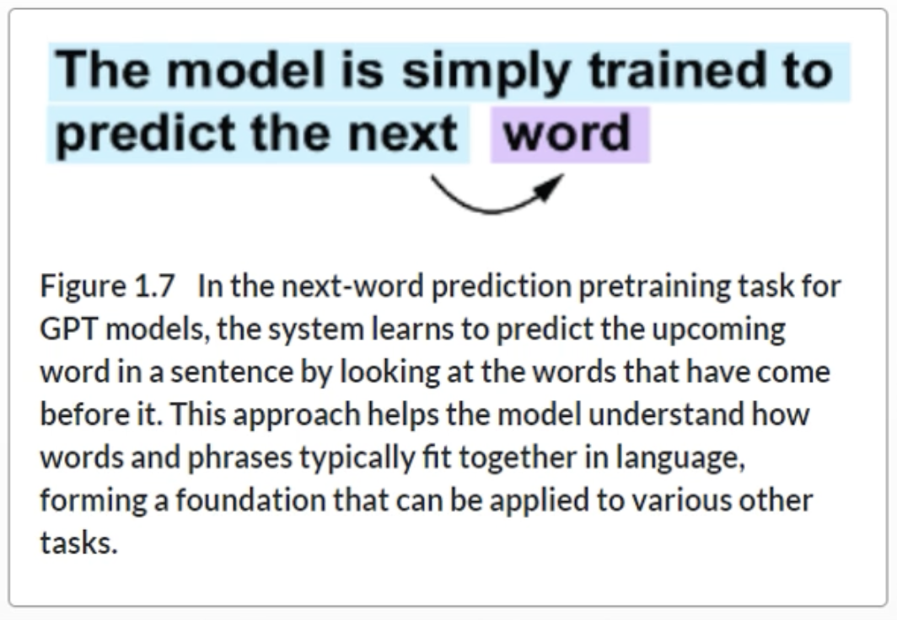

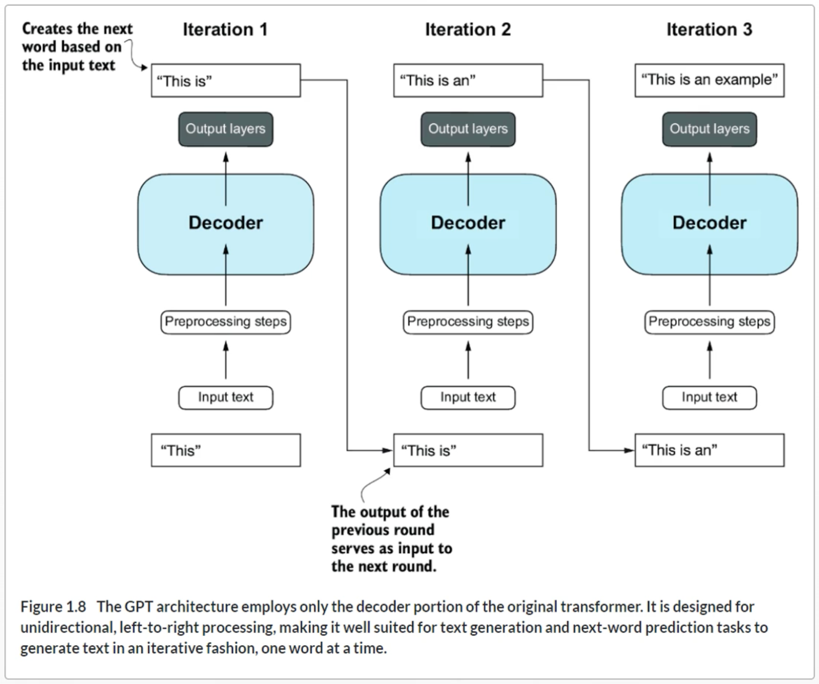

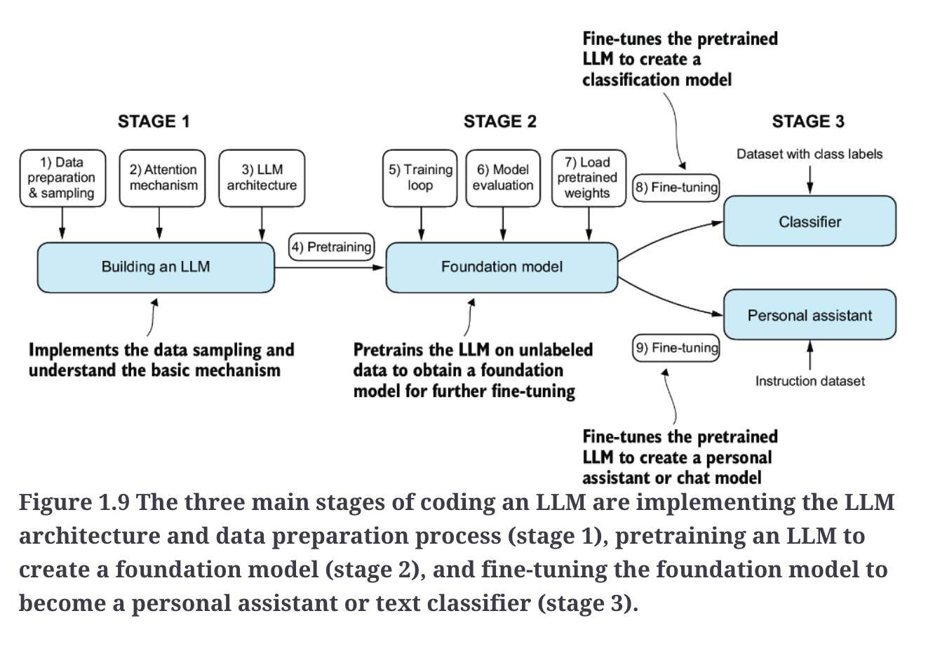

**Summary**

* LLMs have transformed the field of natural language processing, which previously mostly relied on explicit rule-based systems and simpler statistical methods. The advent of LLMs introduced new deep learning-driven approaches that led to advancements in understanding, generating, and translating human language.
* Modern LLMs are trained in two main steps:
  + First, they are pretrained on a large corpus of unlabeled text by using the prediction of the next word in a sentence as a label.
  + Then, they are fine-tuned on a smaller, labeled target dataset to follow instructions or perform classification tasks.
* LLMs are based on the transformer architecture. The key idea of the transformer architecture is an attention mechanism that gives the LLM selective access to the whole input sequence when generating the output one word at a time.
* The original transformer architecture consists of an encoder for parsing text and a decoder for generating text.
* LLMs for generating text and following instructions, such as GPT-3 and ChatGPT, only implement decoder modules, simplifying the architecture.
* Large datasets consisting of billions of words are essential for pretraining LLMs.
* While the general pretraining task for GPT-like models is to predict the next word in a sentence, these LLMs exhibit emergent properties, such as capabilities to classify, translate, or summarize texts.
* Once an LLM is pretrained, the resulting foundation model can be fine-tuned more efficiently for various downstream tasks.
* LLMs fine-tuned on custom datasets can outperform general LLMs on specific tasks.

**Chapter 2**

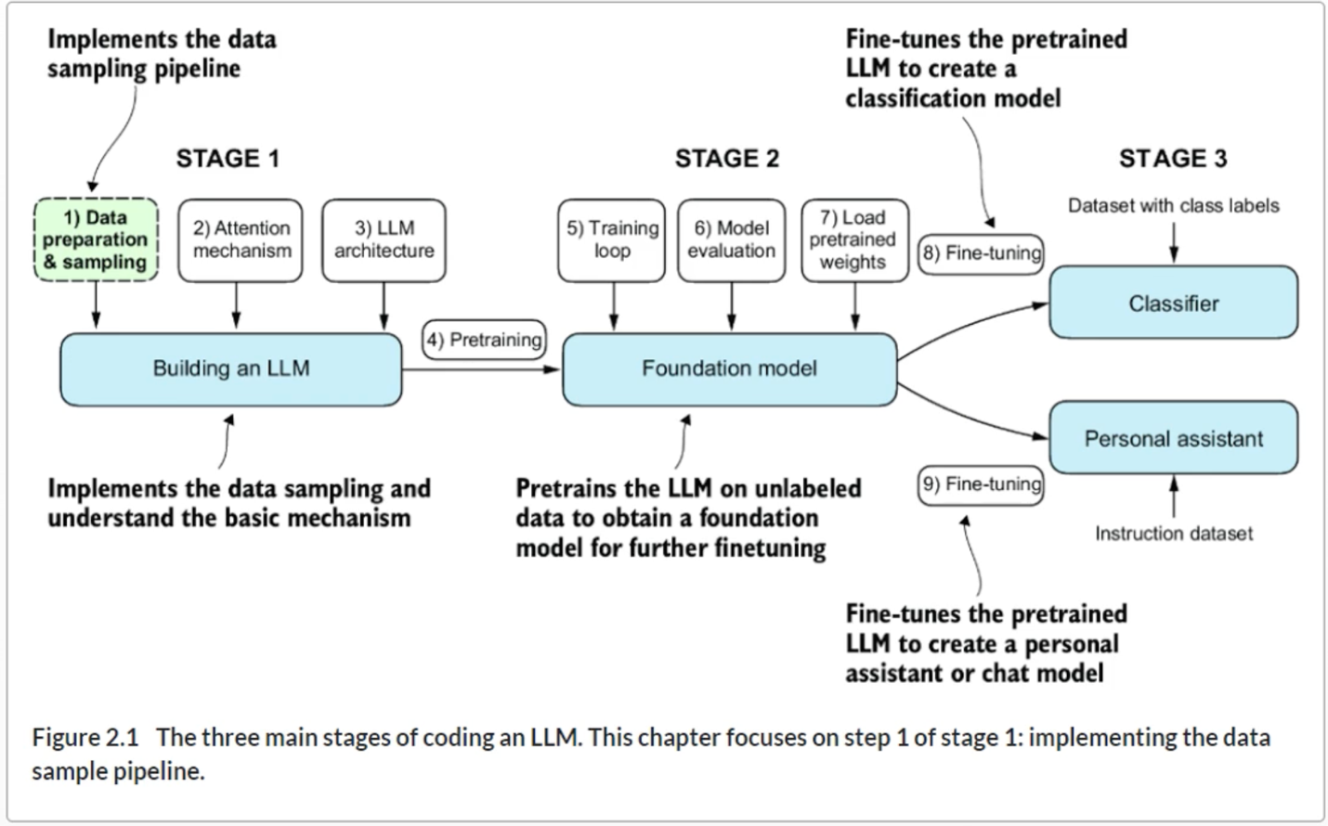

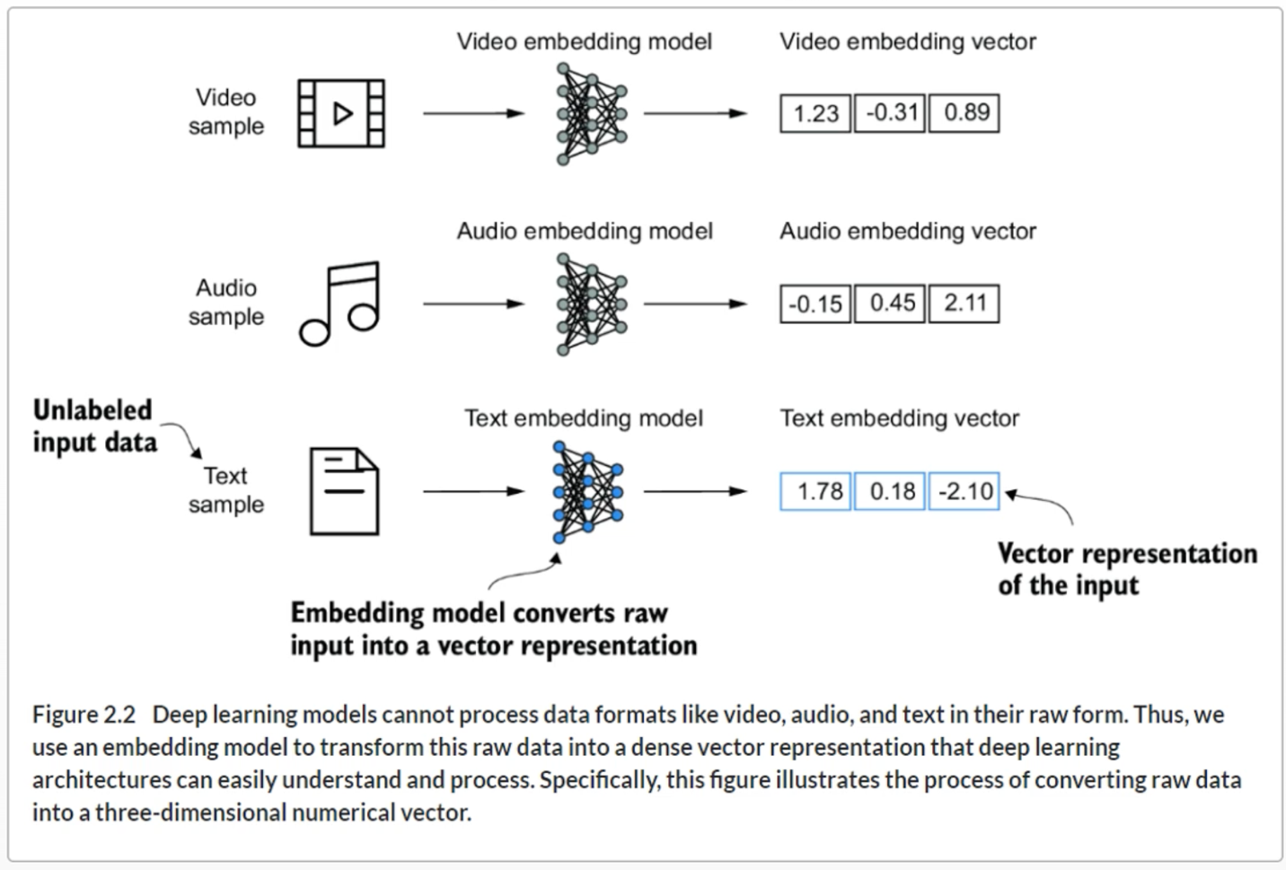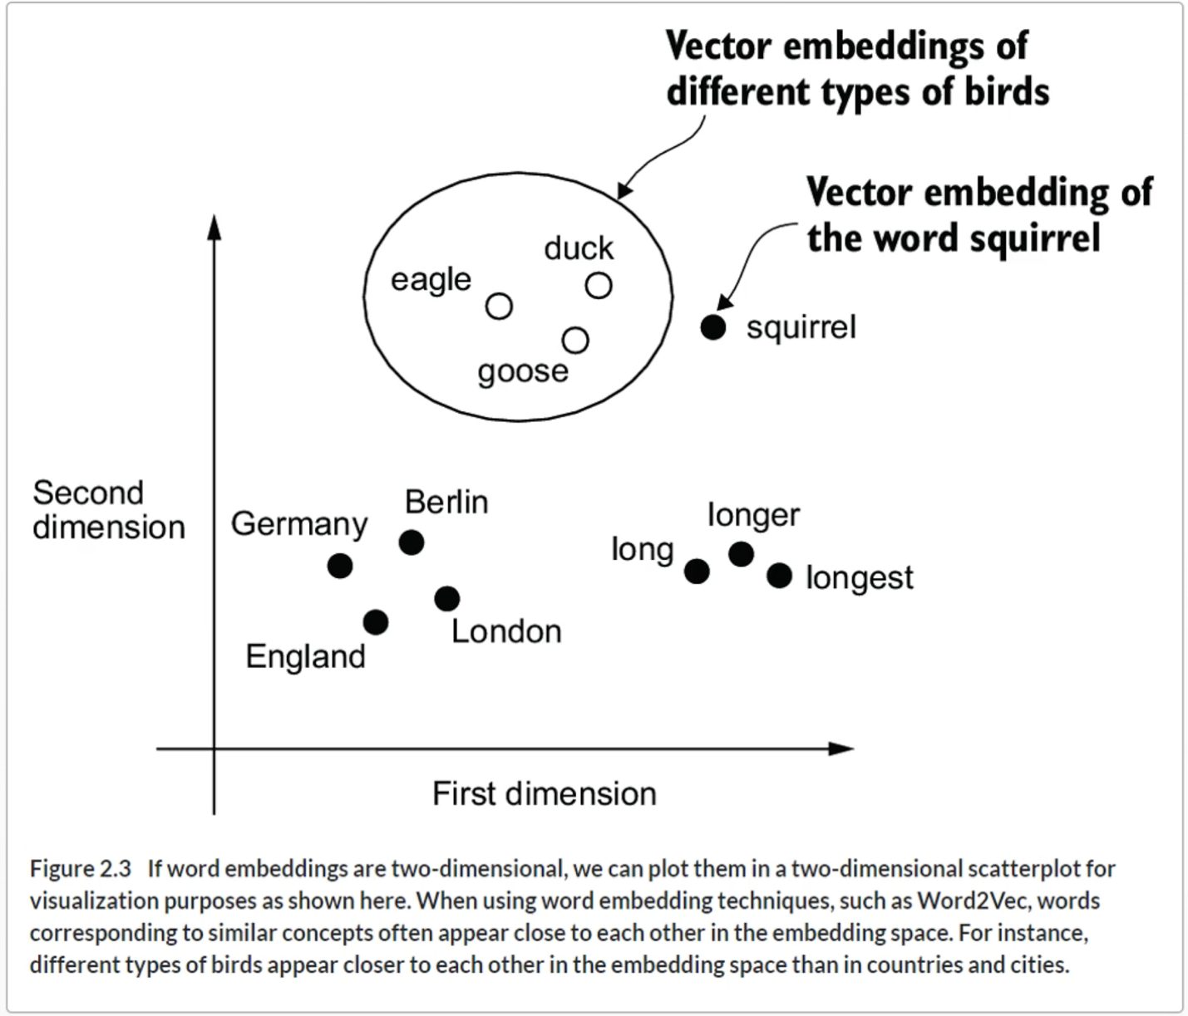

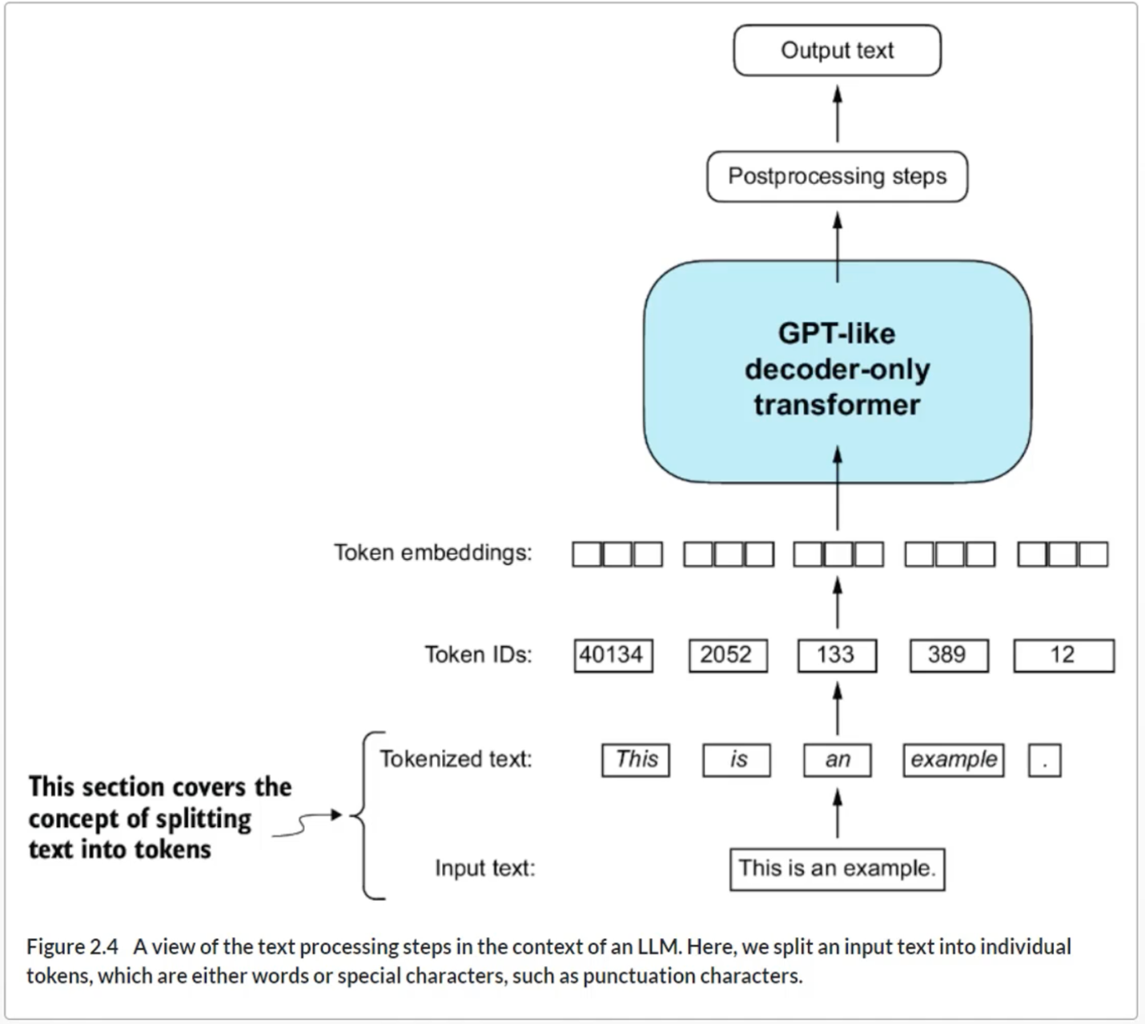

**Tokenization**

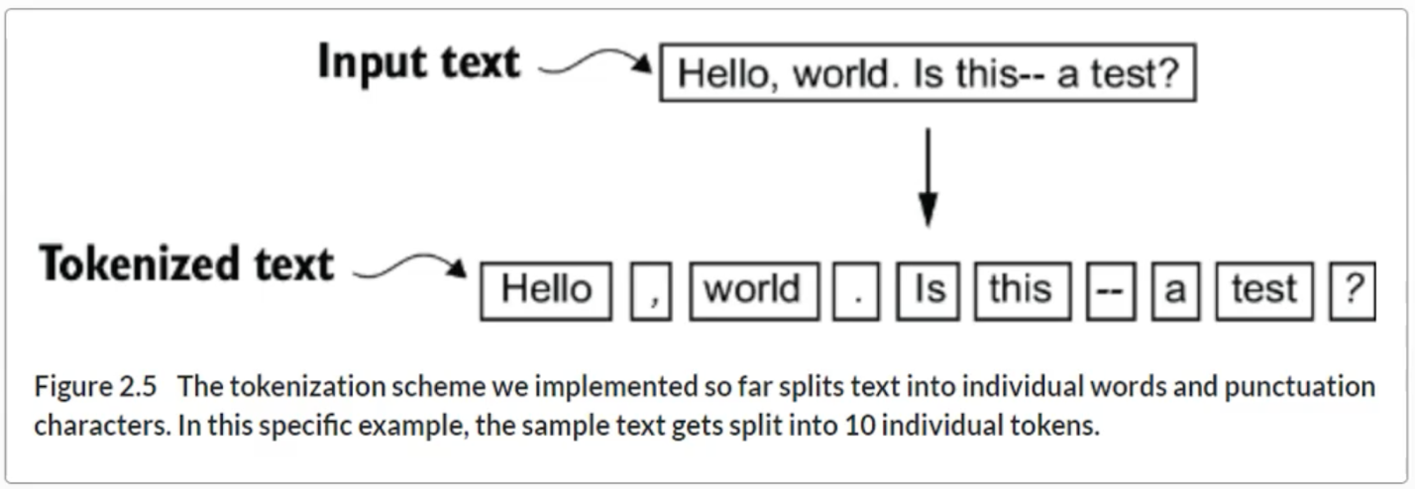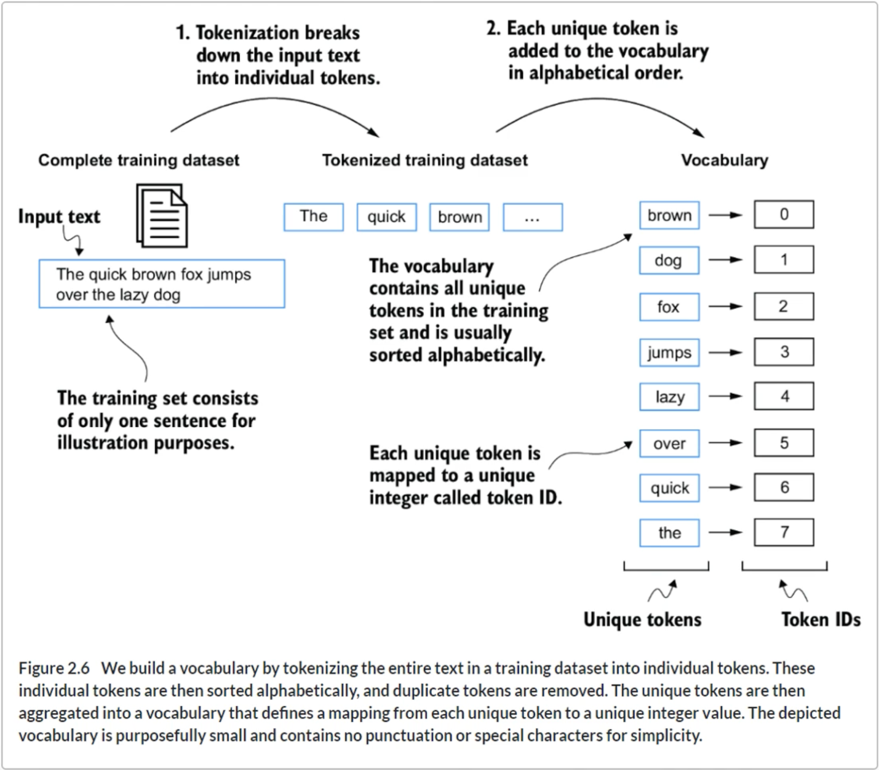

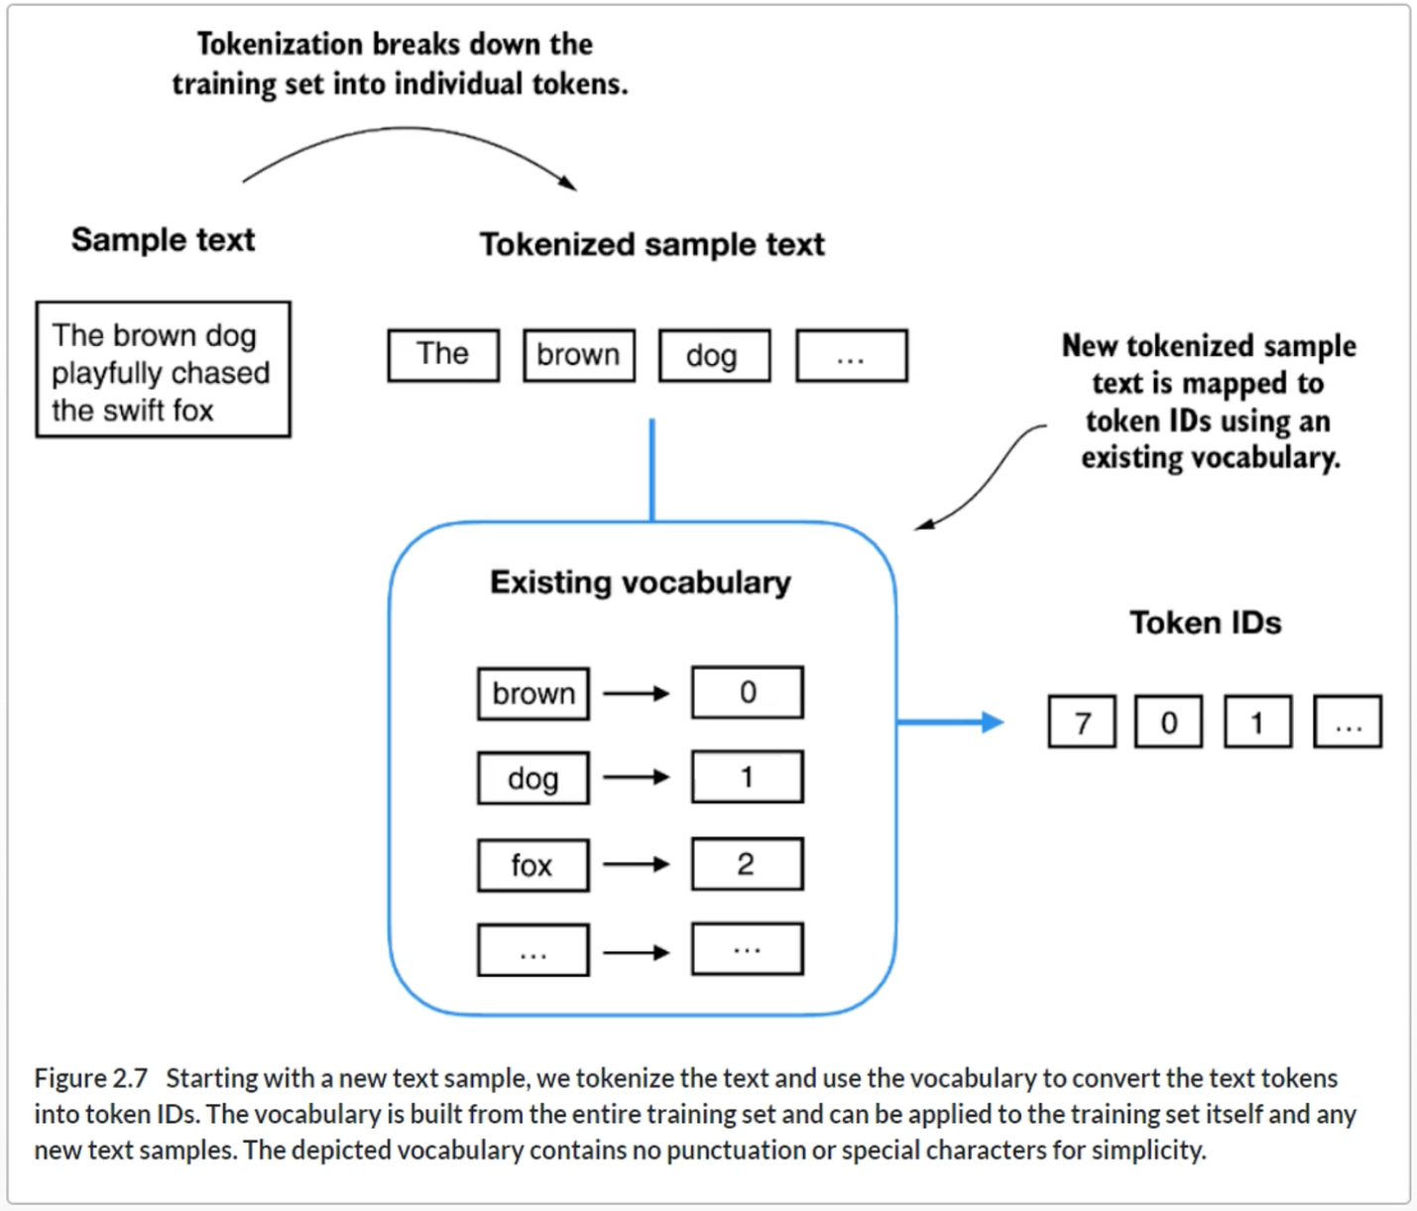

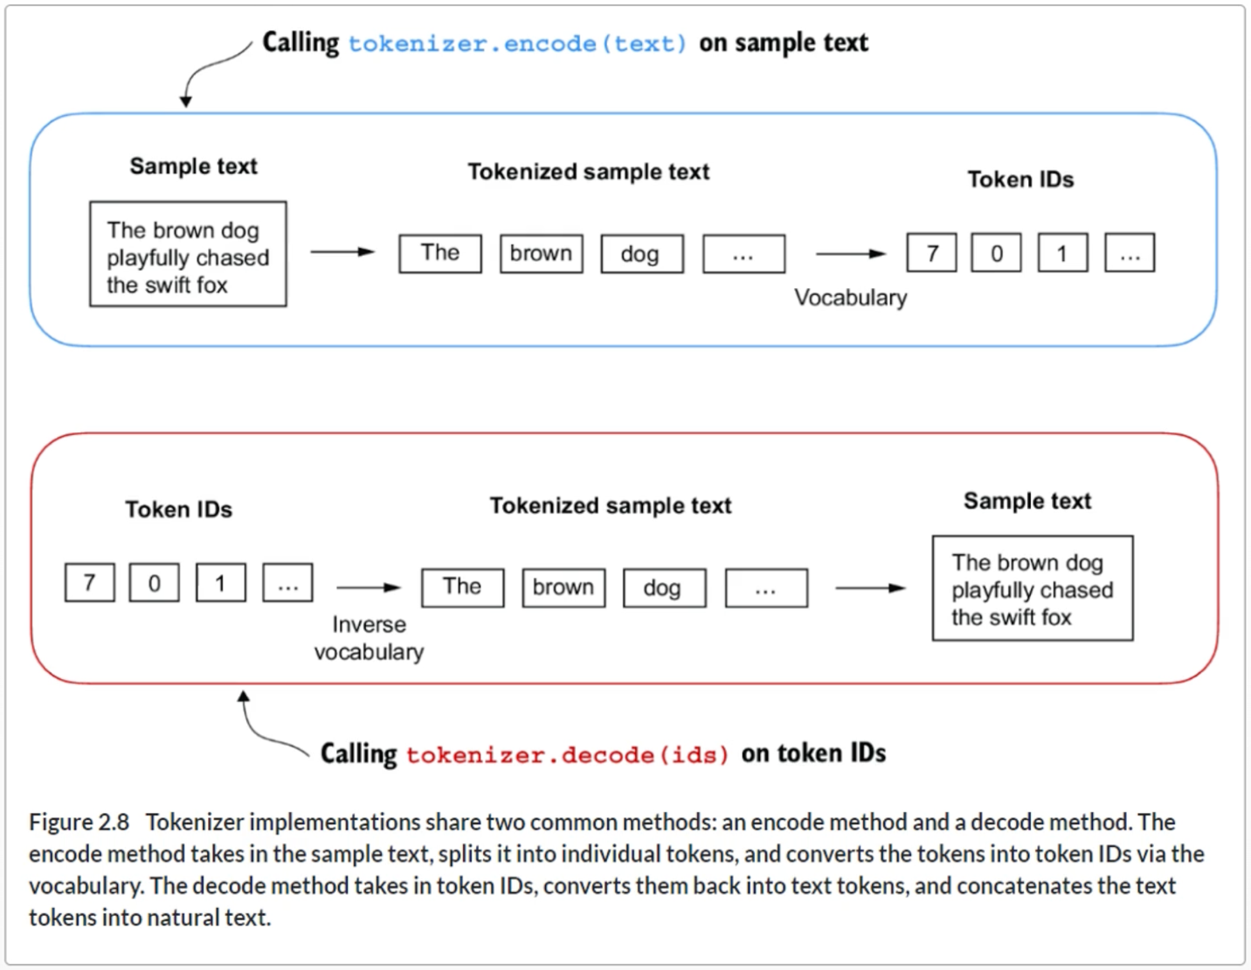

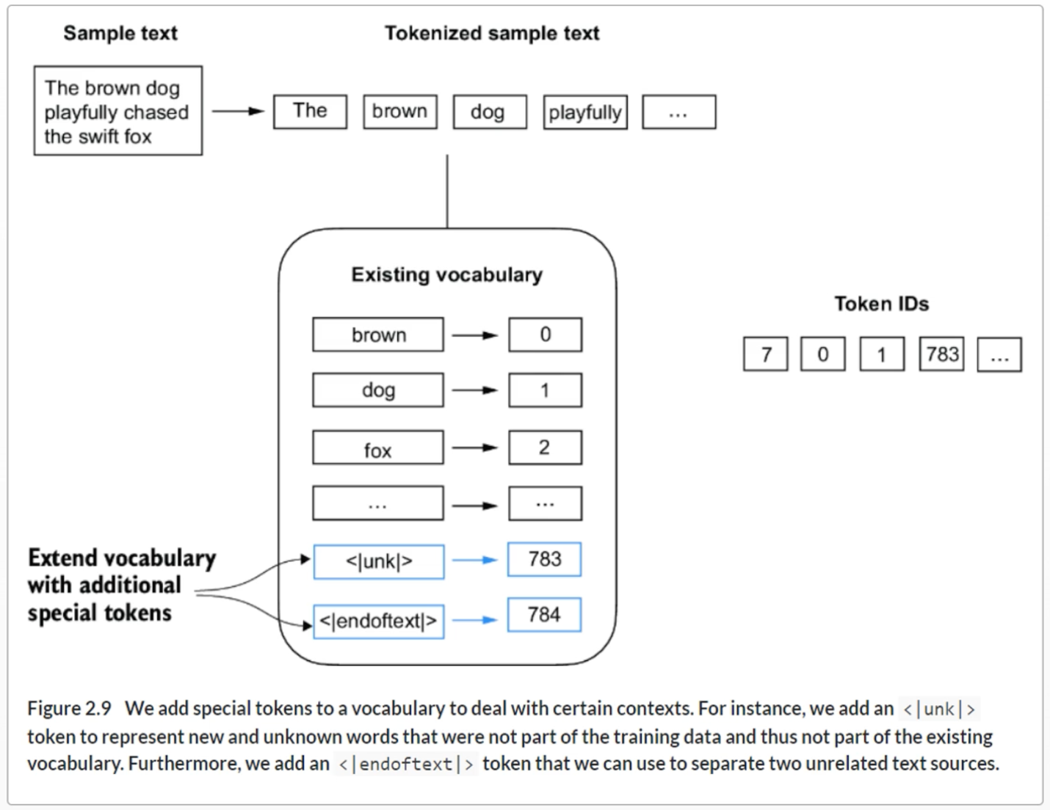

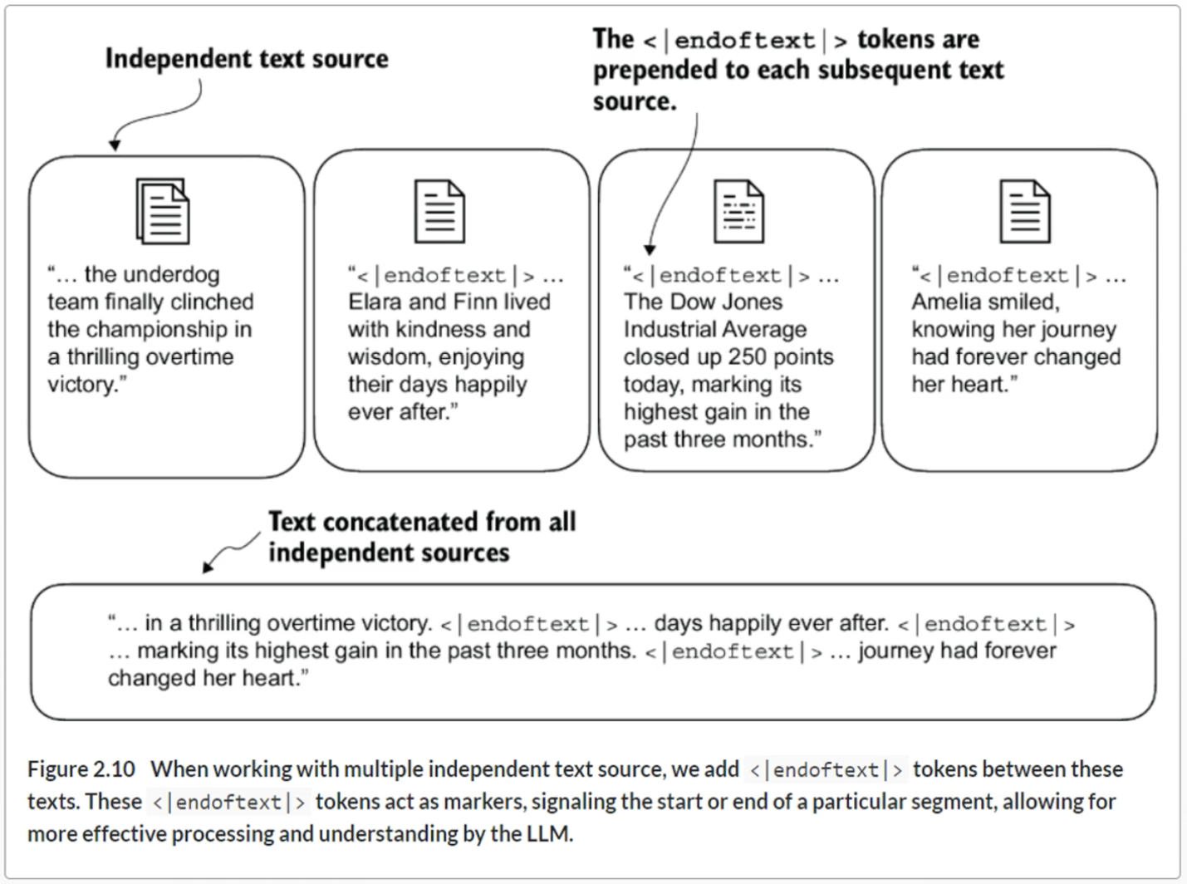

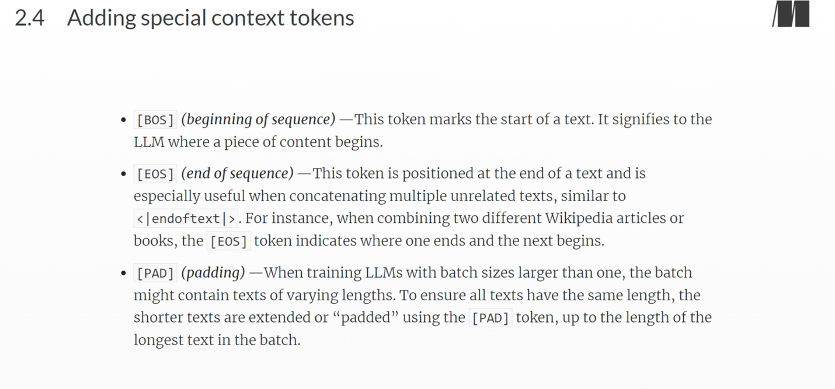

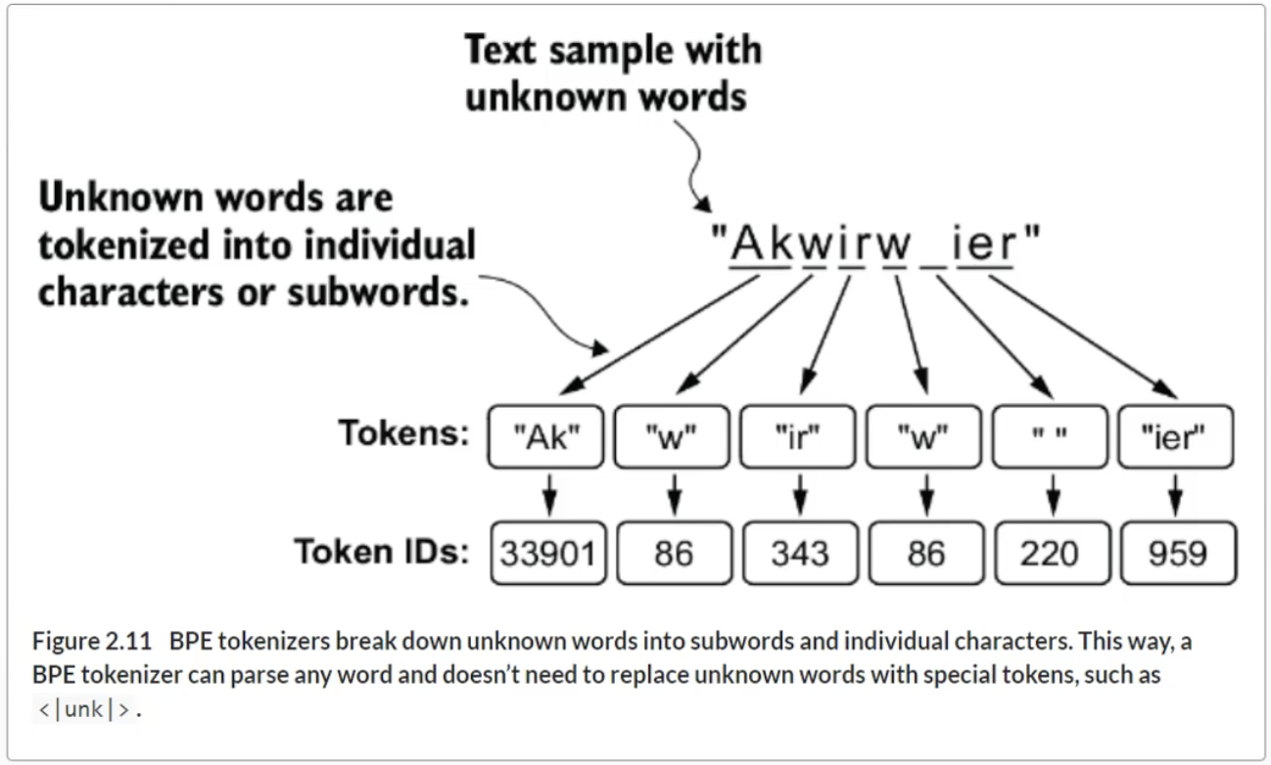

**Data sampling with a sliding window**

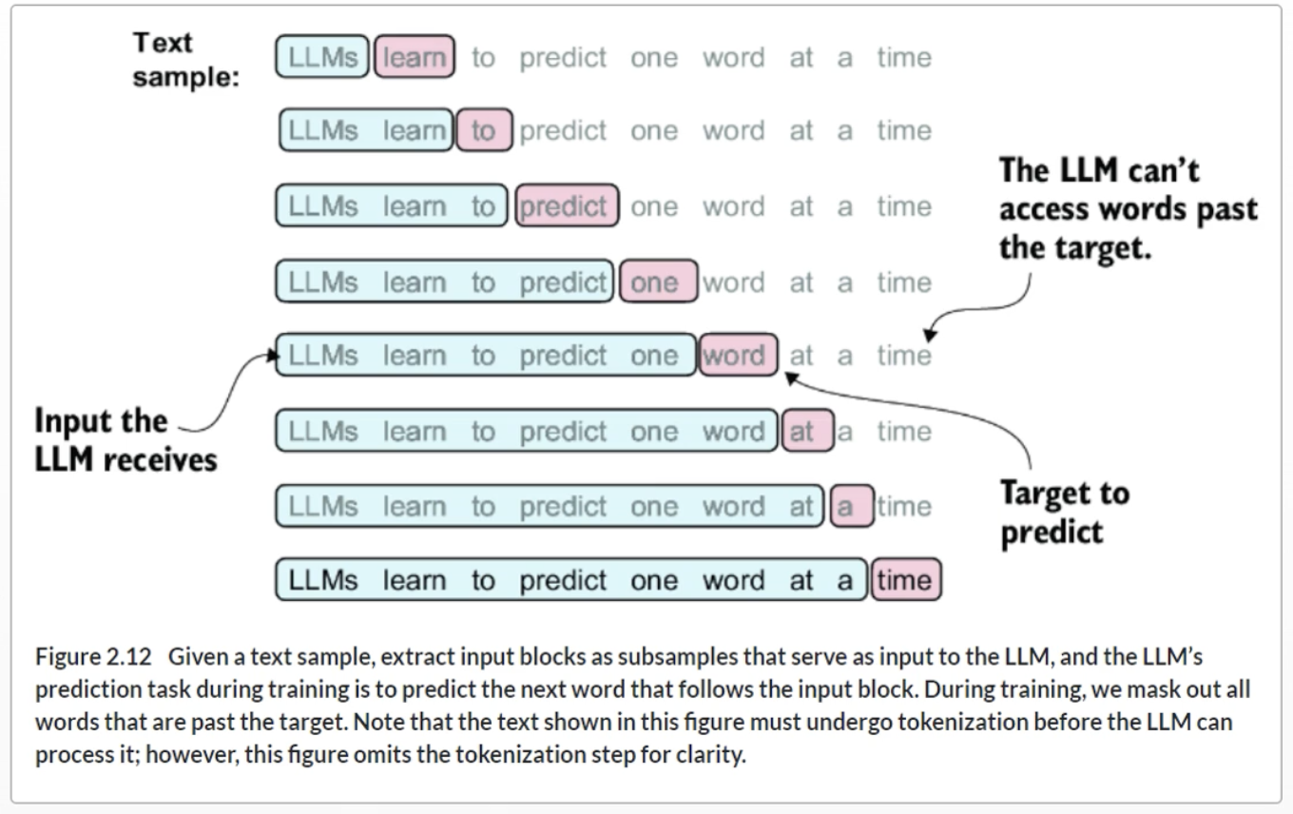

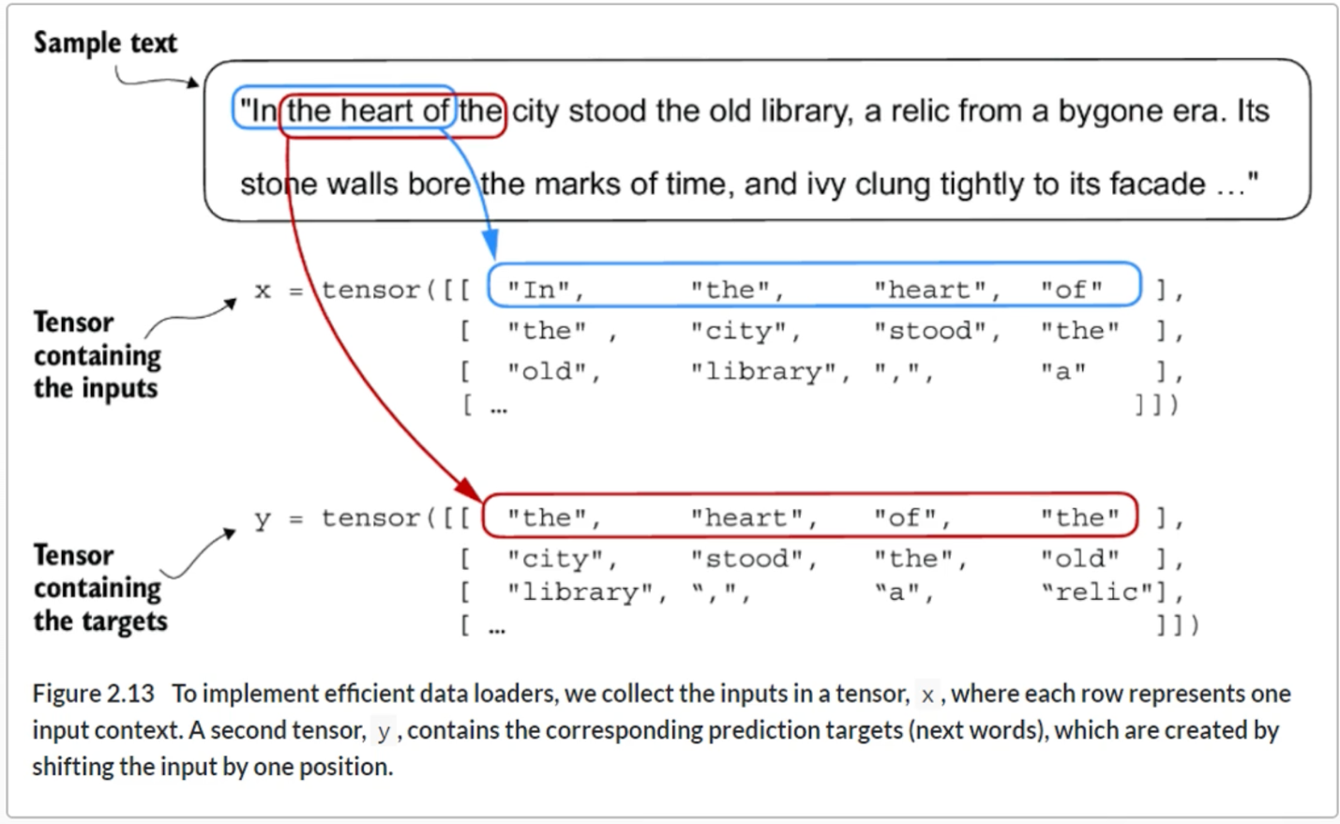

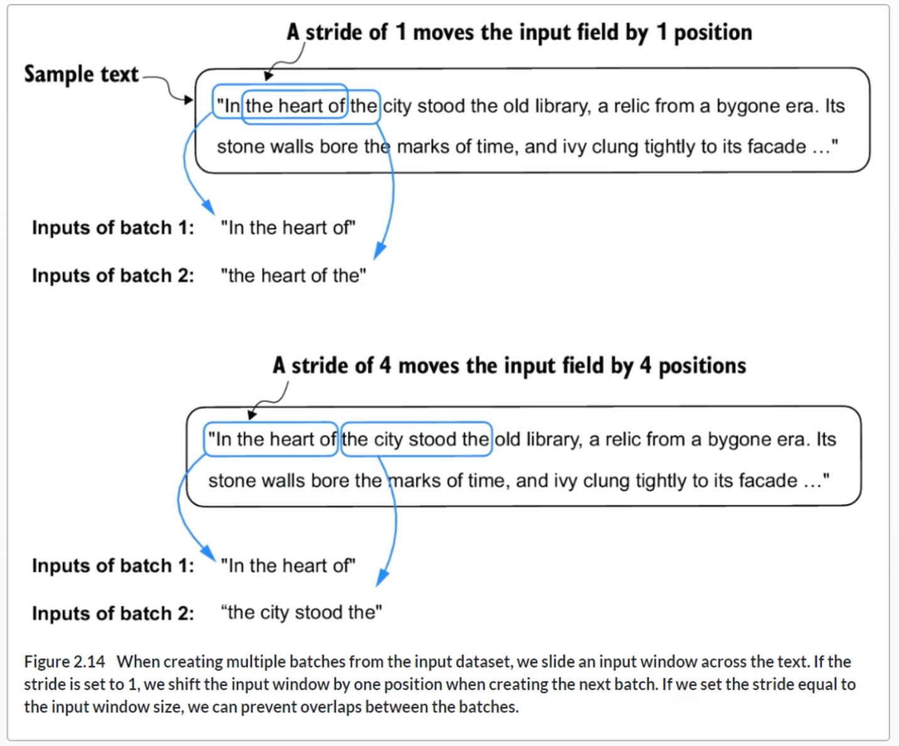

**Creating Token Embeddings**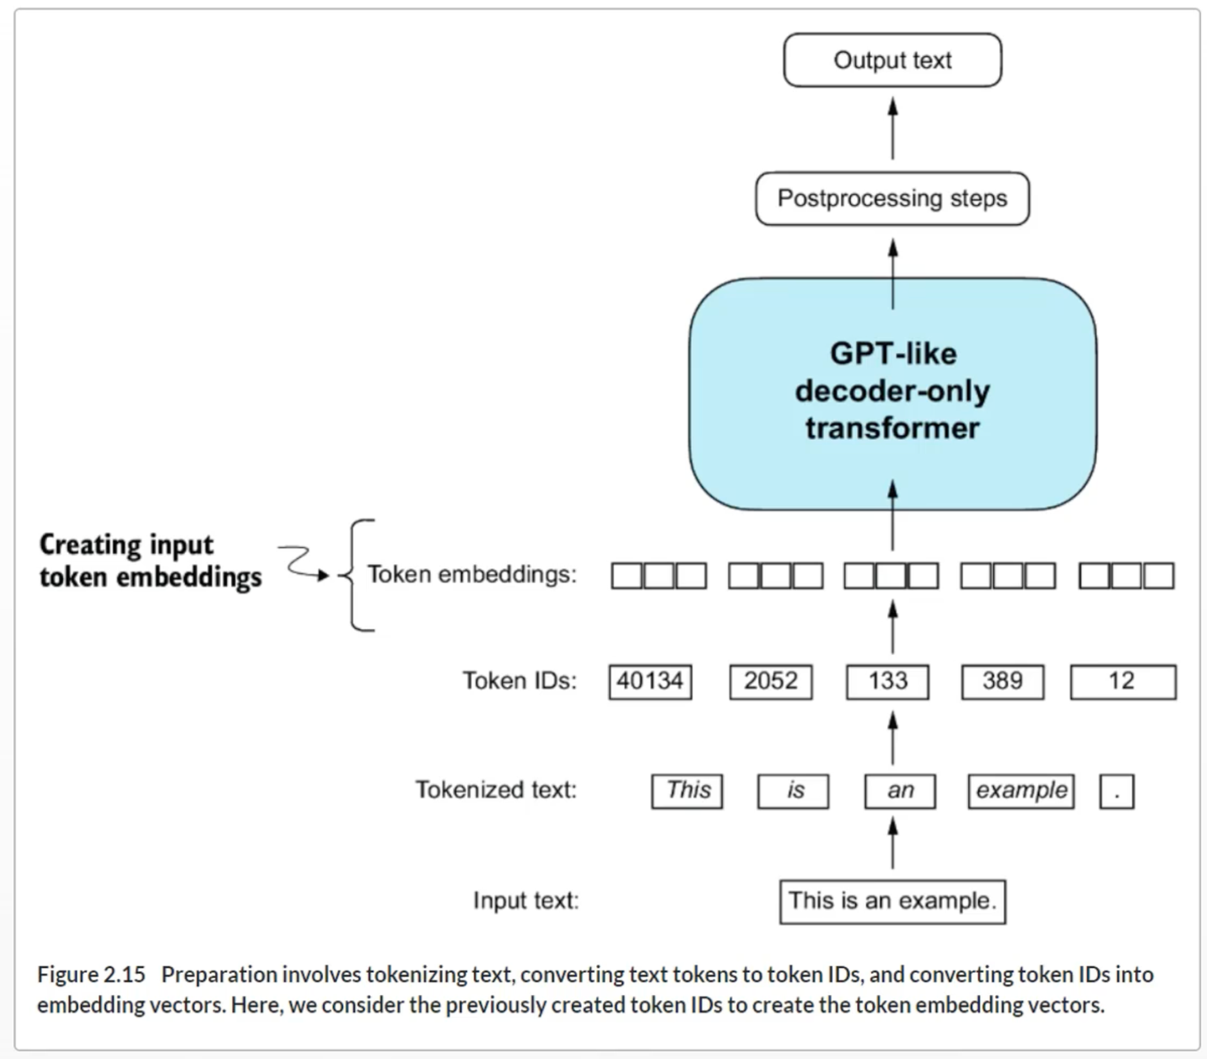

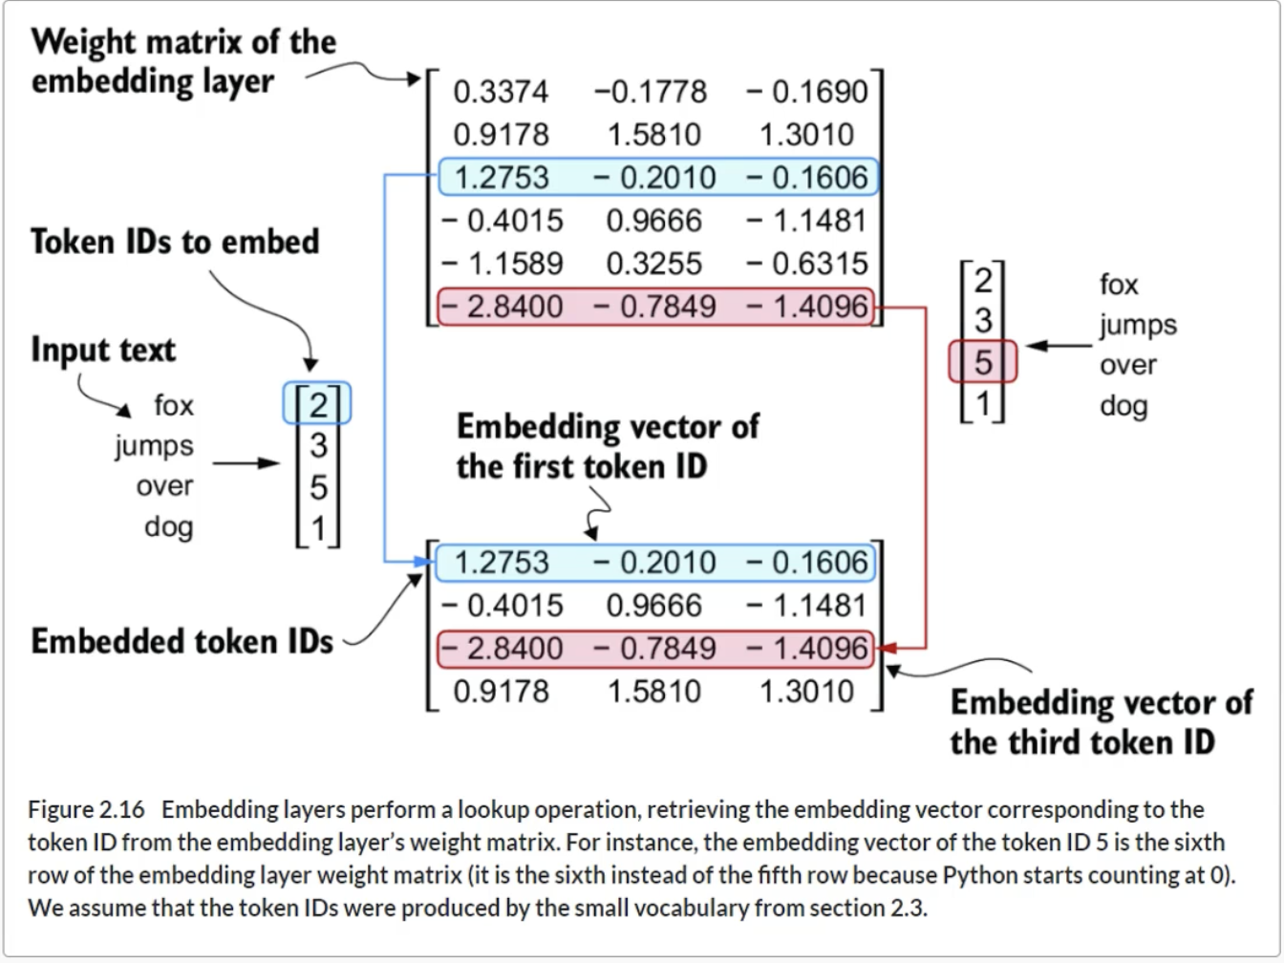

**Positional Encoding**

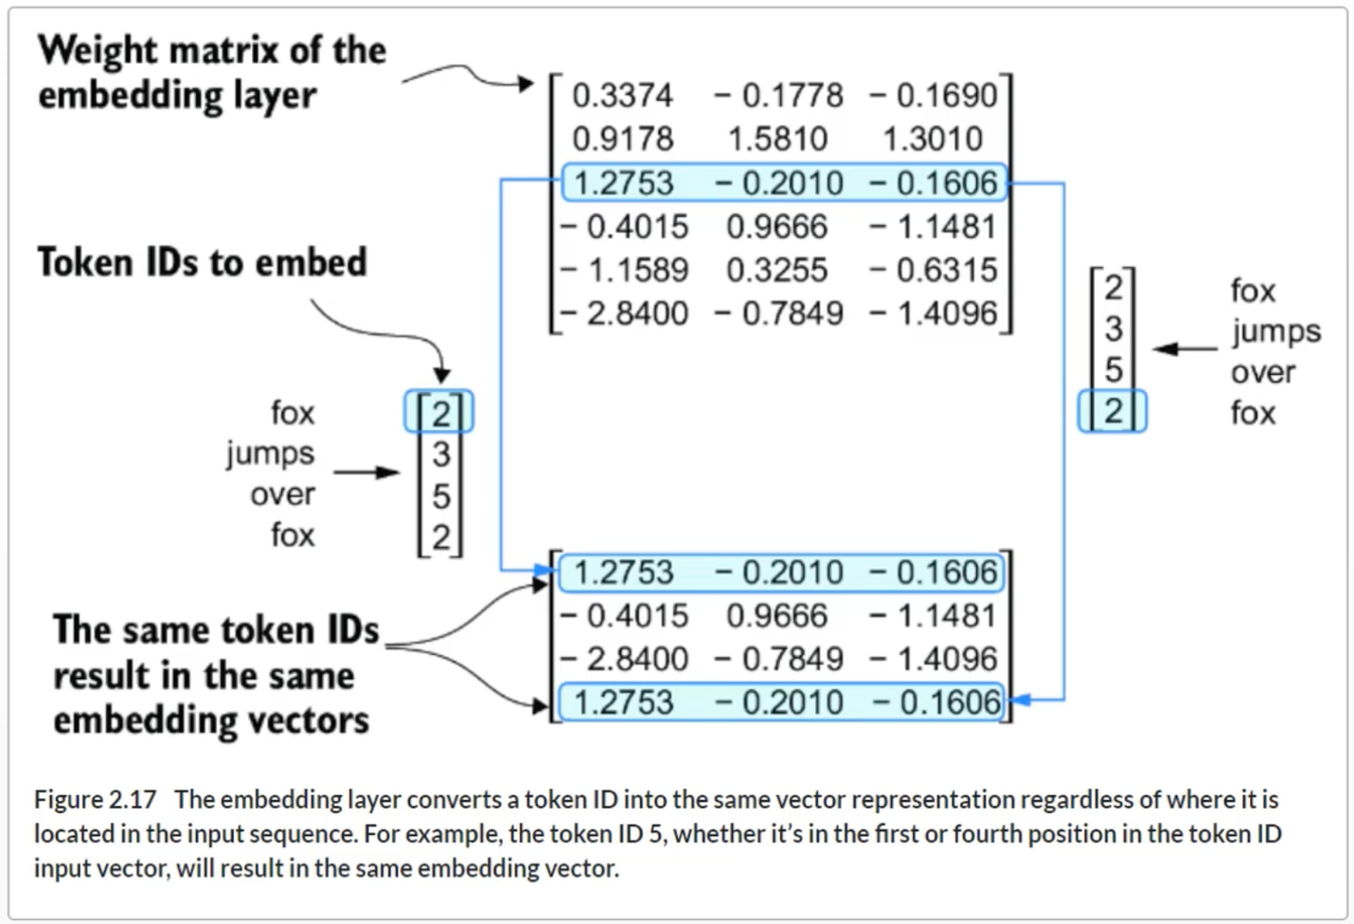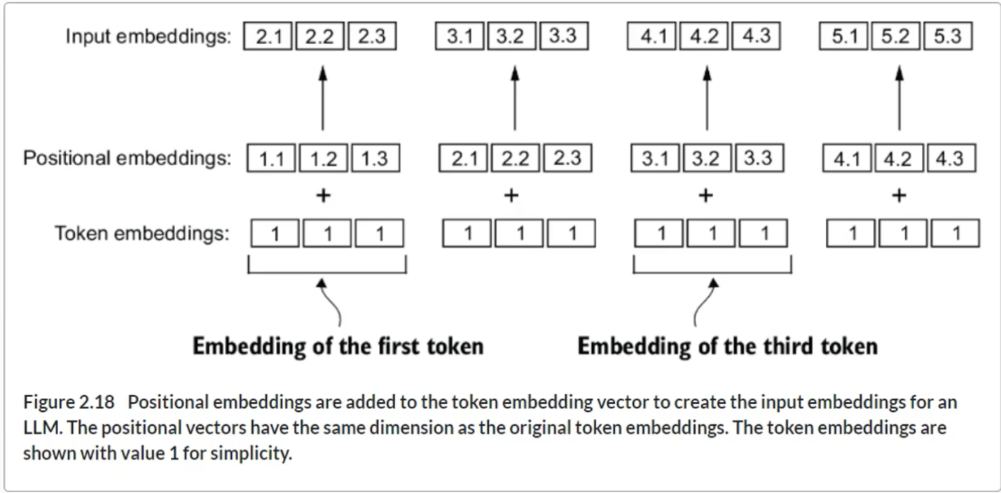

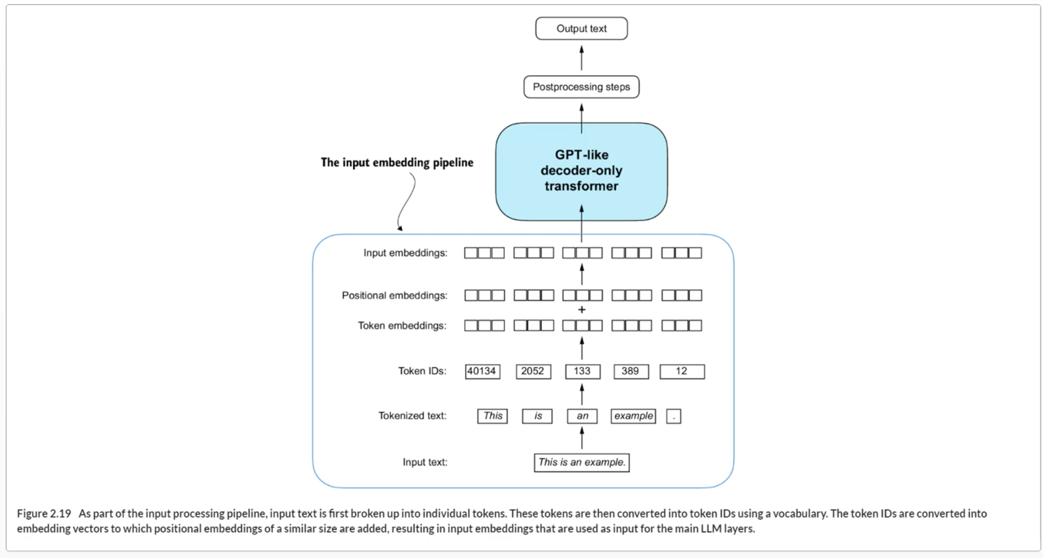

**Chapter 2 Summary**

* LLMs require textual data to be converted into numerical vectors, known as embeddings, since they can’t process raw text. Embeddings transform discrete data (like words or images) into continuous vector spaces, making them compatible with neural network operations.
* As the first step, raw text is broken into tokens, which can be words or characters. Then, the tokens are converted into integer representations, termed token IDs.
* Special tokens, such as <|unk|> and <|endoftext|>, can be added to enhance the model’s understanding and handle various contexts, such as unknown words or marking the boundary between unrelated texts.
* The byte pair encoding (BPE) tokenizer used for LLMs like GPT-2 and GPT-3 can efficiently handle unknown words by breaking them down into subword units or individual characters.
* We use a sliding window approach on tokenized data to generate input–target pairs for LLM training.
* Embedding layers in PyTorch function as a lookup operation, retrieving vectors corresponding to token IDs. The resulting embedding vectors provide continuous representations of tokens, which is crucial for training deep learning models like LLMs.
* While token embeddings provide consistent vector representations for each token, they lack a sense of the token’s position in a sequence. To rectify this, two main types of positional embeddings exist: absolute and relative. OpenAI’s GPT models utilize absolute positional embeddings, which are added to the token embedding vectors and are optimized during the model training.